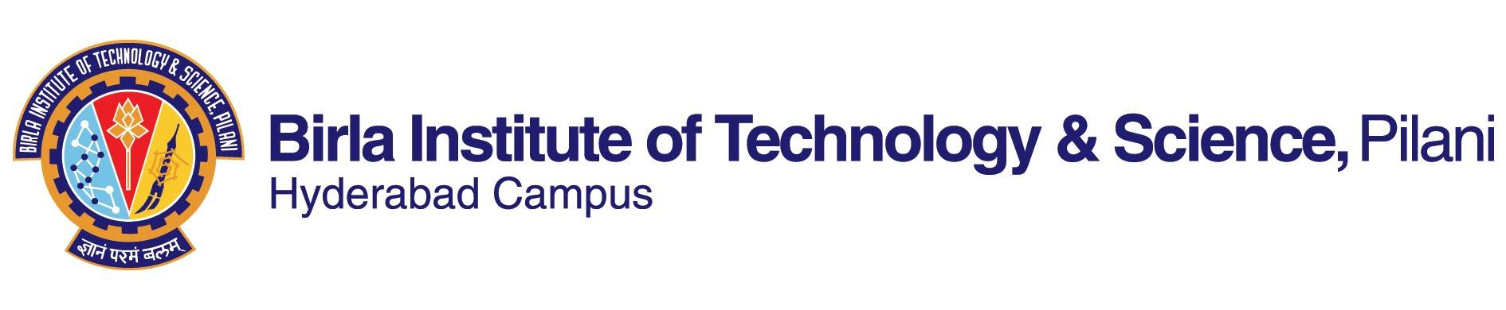

**SECOND SEMESTER 2022-2023**

# Course Handout Part II

Date: 16-01-2023

In addition to Part-I (General Handout for all courses appended to the time table) this portion gives further specific details regarding the course.

*Course No. : CHE F341*

## Course Title : CHEMICAL ENGINEERING LAB-II

## Instructor-in-Charge : Dr. Satyapaul Singh

*Instructors*  : *Prof. Karthik Chetan, Dr. Nandini Bhandaru, and Dr. Afkham Mir*

**Objective of the Course:**

The objective of this lab course is to expose the students to the application of fundamental concepts learnt in their Discipline Courses like Transport phenomena, Selected Chemical Engineering Operations, Process Control and Reaction Engineering.

**Outcome of the Course:**

* Hands-on experience on controller tuning parameters and its effects on process output
* Finding parameters value from the hands-on experiments and validate it with the theoretical value

**Textbooks:**

* + Unit Operations of Chemical Engineering, Warren L. McCabe, Peter Harriott, Julian C. Smith, 7th Edition, McGraw Hill.
  + Mass Transfer Operations, Robert E. Treybal, 3rd Edition, McGraw Hill.
  + Process Dynamics and Control, Dale E. Seborg, Thomas F. Edgar, Duncan A. Mellichamp, Francis J. Doyle III, 4th Edition, Wiley.
  + Elements of Chemical Reaction Engineering, H. Scott Fogler, 4th Edition, PHI publishers.

**Course Plan:**

|  |  |
| --- | --- |
| **Lab Name** | **Experiment Name & Objective** |
| SCEO lab | Adsorption In Packed Bed: To study of adsorption in a packed bed for a solid liquid system. |
| SCEO Lab | Centrifugal Pump: To study of centrifugal pump in series & parallel mode & to find pump characteristics. |
| SCEO Lab | Fluidized Bed Dryer: To study the operation of fluidized bed dryer. |
| SCEO Lab | Natural Draft Tray Dryer: To study the drying characteristics of a solid material under natural draft condition. |
| SCEO Lab | Reciprocating Pump: To study the reciprocating pump characteristics |
| SCEO Lab | Sedimentation Studies: To study of batch sedimentation process. |
| SCEO Lab | Water Cooling Tower: To study mass transfer operation in water cooling tower for different flow & thermodynamic conditions. |
| SCEO Lab | Jaw Crusher: To study the operation of jaw crusher. |
| PC Lab | Pressure Control Trainer: To study the control system in Pressure Control Trainer. |
| PC Lab | Temperature Control Trainer: To study the control system in Temperature Control Trainer. |
| PC lab | Level Control Trainer: To study the control system in Level Control Trainer |
| CRE lab | Batch Reactor: To study the order and rate constant for the reaction between sodium hydroxide and ethyl acetate in a batch reactor. |
| CRE lab | Continuous Stirred Tank Reactor: To study the order and rate constant for the reaction between sodium hydroxide and ethyl acetate in a CSTR. |
| CRE lab | Plug Flow Reactor: To study the order and rate constant for the reaction between sodium hydroxide and ethyl acetate in a PFR. |
| CRE lab | Cascaded CSTR (CSTR In Series): To compare the conversion of reactants between a single CSTR and CSTRs in series. |
| CRE lab | CSTR & PFR in Series: To compare the conversion of reactants between PFR and CSTR & PFR in series. |
| SCEO lab, demo | Batch Crystallizer: To study the crystallization of MgSO4. 7H2O in a batch crystallizer. |
| SCEO Lab, demo | Ball mill: to study the cumulative & differential plots of sieve analysis & find out various diameters. |
| SCEO Lab, demo | Plate & Frame Filter Press: To study the operation of plate and frame filter press. |
| SCEO Lab, demo | Double Effect Evaporator: To concentrate the sodium carbonate solution |
| PC Lab, demo | pH Control Trainer: To study the control system in pH Control Trainer. |
| Instrumentation Lab, demo | Spectrophotometer: To find unknown concertation of a color solution using spectrophotometric method. |

**Evaluation Scheme:**

|  |  |  |  |  |
| --- | --- | --- | --- | --- |
| **Component** | **Duration** | **Weightage (%)** | **Date & Time** | **Nature of Component** |
| Lab. Expt (SCEO) | 30 hrs | 25 | During lab sessions | Open book |
| Lab. Expt (PC& CRE) | 30 hrs | 25 | During lab sessions | Open book |
| Viva – 1 (SCEO/PC&CRE) | 3 hrs | 15 | During lab sessions | Closed Book |
| Viva – 2 (SCEO/PC&CRE) | 3 hrs | 15 | During lab sessions | Closed book |
| Written test | 1hr | **20** | **TBA** | Closed Book |

**Chamber Consultation Hour:** To be announced in the class.

**Notices:** All notices concerning this course will be displayed on the Notice Board of Chemical Engineering or CMS

**Make-up Policy:** Make-up for the tests may be granted only with prior permission and valid justification from the Instructor-in-charge.

**Academic Honesty and Integrity Policy:**

Academic honesty and integrity are to be maintained by all the students throughout the semester and no type of academic dishonesty is acceptable.

**INSTRUCTOR-IN-CHARGE**

**Dr. Satyapaul Singh**